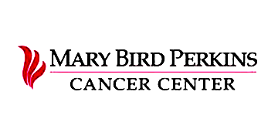

Rebecca Herin and Taylor Vu
Final Campaign Plan
MC 4002
9 December 2021
Table of Contents
Introduction………………………………………………………………………3
Situation Analysis………………………………………………………………..4
Research………………………………………………………....…….……...….5
Planning………………………………………………………………………….6
Implementation……………………………………………………………....…..7
Evaluation……………………………………………………………………….11

Introduction
Executive Summary
In the late 1960s, community leaders saw the need for a nonprofit, community-owned radiation facility in the greater Baton Rouge area. For the past 50 years, Mary Bird Perkins Cancer Center’s mission has been to improve survivorship and lessen the burden of cancer through expert treatment, early detection, research and education. The facilities serve cancer patients in Louisiana and specialize in treating breast cancer, cervical cancer, colorectal cancer, esophageal cancer, liver cancer, lung cancer, pancreatic cancer, prostate cancer, skin cancer and oral, head and neck cancer. Mary Bird Perkins and its partners work together to provide accurate information and education about cancer, state-of-the-art treatments as well as collaborative, comprehensive cancer services.

Mary Bird Perkins announced a new partnership with OneOncology after a long partnership with Our Lady of the Lake Hospital on Aug. 18, 2021. The news of Mary Bird Perkins ending a long-standing partnership with a local hospital was cause for concern for many. This threat serves as an opportunity for Mary Bird Perkins to rebuild community trust and strengthen its communication efforts.

This communication plan has two goals:
- To reinstate Mary Bird Perkins Cancer Center as a leader in cancer treatment for Louisiana residents
- To increase social media and website engagement

This comprehensive, communication plan provides Mary Bird Perkins Cancer Center with a detailed analysis of its target audiences, key messages and social media presence, as well as key strategies for social media communications and community outreach.

Situation Analysis
SWOT Analysis
Mary Bird Perkins Cancer Center’s main strength is its longstanding commitment to providing premier cancer treatment to the people of Louisiana. The cancer center’s weakness is a recent change in partnership from the local Our Lady of the Lake Hospital to OneOncology, a national for-profit organization. However, the 50th anniversary of Mary Bird Perkins Cancer Center provides an opportunity to reconnect with Louisiana residents and donors while quelling nerves about the possible threat of no longer being affiliated with Our Lady of the Lake Hospital.

Media Coverage
Mary Bird Perkins and Our Lady of the Lake began a partnership in 1992 and ended after disagreements under the terms of a new deal. With the recent media coverage of the ending partnership, Our Lady of the Lake reiterated its mission to never step away from what is right for monetary gain compared to Mary Bird Perkins. Our Lady of the Lake’s response to the new partnership has called many to question the integrity and care that Mary Bird Perkins provides.

Communication Audit
Mary Bird Perkins Cancer Center has a wide social media presence with active accounts on Instagram, Facebook, LinkedIn and Twitter. All of Mary Bird Perkins Cancer Center’s social media accounts have around 1,000 followers. The social media accounts promote an image and reputation of a state-of-the-art cancer treatment center dedicated to the Louisiana community. Recently, Mary Bird Perkins has launched communication efforts concerning awareness. In October, Mary Bird Perkins used the hashtag, #GeauxPink, to raise awareness for breast cancer. Currently, the cancer center is focusing on raising awareness for pancreatic cancer awareness month. The communications of Mary Bird Perkins Cancer Center show strong, professional and caring language. Mary Bird Perkins uses social media as a chance to promote, educate and raise awareness.

Competitive Frame
Mary Bird Perkins announced a new partnership with OneOncology after a long partnership with Our Lady of the Lake Hospital on Aug. 18, 2021. The hospital anticipates program growth, lower cost for patients and expanded access to clinical trials. The new partnership is expected to mutually aid each organization toward a common goal of delivering a patient-centric, physician-driven and technology-powered cancer care model to improve survivorship. Our Lady of the Lake Cancer Center released a statement in response to the new partnership that communicated its sadness to see a once-trusted partner make a financial sale of a community’s non-profit asset. Our Lady of the Lake’s response has called up questions for current partners, donors and patients to reassess their trust in Mary Bird Perkins.

Research
Secondary Research
Mary Bird Perkins Cancer Center is Louisiana’s leading cancer care organization and has been caring for more patients each year than any other facility in the Baton Rouge area. For the past 50 years, the hospital’s mission has been to improve survivorship and lessen the burden of cancer through expert treatment, early detection, research and education. Mary Bird Perkins has ongoing partnerships with other hospitals and physicians to provide state-of-the-art, comprehensive treatments and services. Through the support from the community and partner organizations, the nonprofit gives 100% of donations back to the community.

In the late 1960s, community leaders saw the need for a nonprofit, community-owned radiation facility in the greater Baton Rouge area. Through the overwhelming emotional and financial support from the community, Mary Bird Perkins Radiation Treatment Center opened its doors in 1971. Today, Mary Bird Perkins remains the leader in providing radiation therapy and bringing early detection programs across southeast Louisiana and parts of Mississippi. The hospital was founded by a community initiative and through the support of the community, still serves the surrounding area to meet future challenges of providing innovative technology and community cancer care to its patients.

Key Publics
This campaign seeks to assure the people of Louisiana that Mary Bird Perkins Cancer Center will continue to provide world-class cancer treatment and education to the people of Louisiana, despite the change in partnership. The campaign will focus on building trust with current patients, current medical professionals, and those who are in the need of cancer screenings. This campaign will soothe anxiety about the change in partnership and will restore Mary Bird Perkins as a trusted cancer facility.

Mary Bird Perkins Cancer Center serves cancer patients in Louisiana and specializes in treating breast cancer, cervical cancer, colorectal cancer, esophageal cancer, liver cancer, lung cancer, pancreatic cancer, prostate cancer, skin cancer and oral, head and neck cancer. The key publics for this campaign are current cancer patients, people in the age range where cancer screenings are suggested and oncology doctors, nurses and staff. The key publics will be broken into different segments in order to best target these audiences. Demographically, there are three audiences: men ages 30 to 80, women ages 30 to 80 and Mary Bird Perkins staff. Psychographically, one key audience is cancer patients in Louisiana. All of these audiences will be targeted through different Facebook and Instagram tactics as well as a community event.

The primary audience for this campaign are current cancer patients. The primary audience consists of both men and women in Louisiana ages 30 to 80. The secondary audience for this campaign are those who are of age to be screened for cancer and the medical community in Louisiana as well as the staff at Mary Bird Perkins. This audience also consists of both men and women in Louisiana and ages 30 to 80. Both audiences have a wide range of marital statuses, ethnicities, employment statuses, incomes and family sizes. However, according to the National Cancer Institute, 85.2% of Louisiana cancer patients have at least a high school education, 62% are white, and 51% are female. The target audience’s age range typically responds best to simple communications with visuals that use positive language while acknowledging the target audience’s emotions. The age range of the target audience also predominantly uses Facebook and Instagram.

Planning
Goals and Objectives
Mary Bird Perkins Cancer Center has served the needs of patients throughout the Baton Rouge community for the past 50 years through state-of-the-art treatment and education. The goal of this campaign is to reinstate Mary Bird Perkins as a leader in cancer treatment in the community, to increase awareness about the services and treatments that Mary Bird Perkins Cancer Center provides and to increase social media engagement.

This campaign will execute three objectives in order to meet these goals. The objectives for Mary Bird Perkins Cancer Center include: to have at least 200 families attend a family fun day on Dec. 15th in honor of Mary Bird Perkins’ 50th-anniversary, to have a 15% increase in website traffic by Dec. 21st and to have a 15% increase in social media engagement on both Facebook and Instagram by Dec. 21st.

Themes and Messages
The theme of the campaign will be to reinstate Mary Bird Perkins Cancer Center as the leading cancer treatment facility, loyal in the Baton Rouge community. Several key messages will be used to reach the target audience: Mary Bird Perkins and its partners work together to provide state-of-the-art treatments and collaborative, comprehensive cancer services, the organization will continue providing accurate information and education about cancer to the community and reinforce the idea that Mary Bird Perkins and its partnerships are wholly dedicated to patient care. The campaign will use both a rational and emotional message approach to communicate that Mary Bird Perkins Cancer Center has delivered the most advanced cancer care through compassion and excellence and remains a community leader.

Implementation
Strategies and Tactics
Mary Bird Perkins Cancer Center is Louisiana’s leading cancer care organization and has been caring for more patients each year than any other facility in the Baton Rouge area for the past 50 years. This campaign seeks to assure the people of Louisiana that Mary Bird Perkins Cancer Center will continue to provide world-class cancer treatment and education to the people of Louisiana, despite a recent change in partnership. To achieve this campaign’s desired objectives, this campaign will compose Facebook and Instagram posts that showcase Mary Bird Perkins Cancer Center’s doctors and cancer expertise. By posting about the doctors and cancer experts, Mary Bird Perkins will remain transparent with the Baton Rouge community. The campaign will also include a family fun day event to re-engage Mary Bird Perkins with the community.

With the recent partnership announcement with OneOncology, Mary Bird Perkins has received backlash after separating with Our Lady of the Lake. Media coverage has put Mary Bird Perkins in a position where it must assure Baton Rouge community members that the hospital is still community focussed. Through transparency and engagement, Mary Bird Perkins will assure the people of Louisiana that it will continue to provide world-class cancer treatment and education to the surrounding communities.

This campaign will launch a social media initiative to gain interactions for Mary Bird Perkins Cancer Center’s Facebook and Instagram. The posts will not only gain interactions but will also drive traffic to the Mary Bird Perkins website as well as assert Mary Bird Perkins’ reliability for cancer treatment. The first set of posts will showcase the brilliant doctors working for Mary Bird Perkins using the hashtag #MeetOurDoctors.
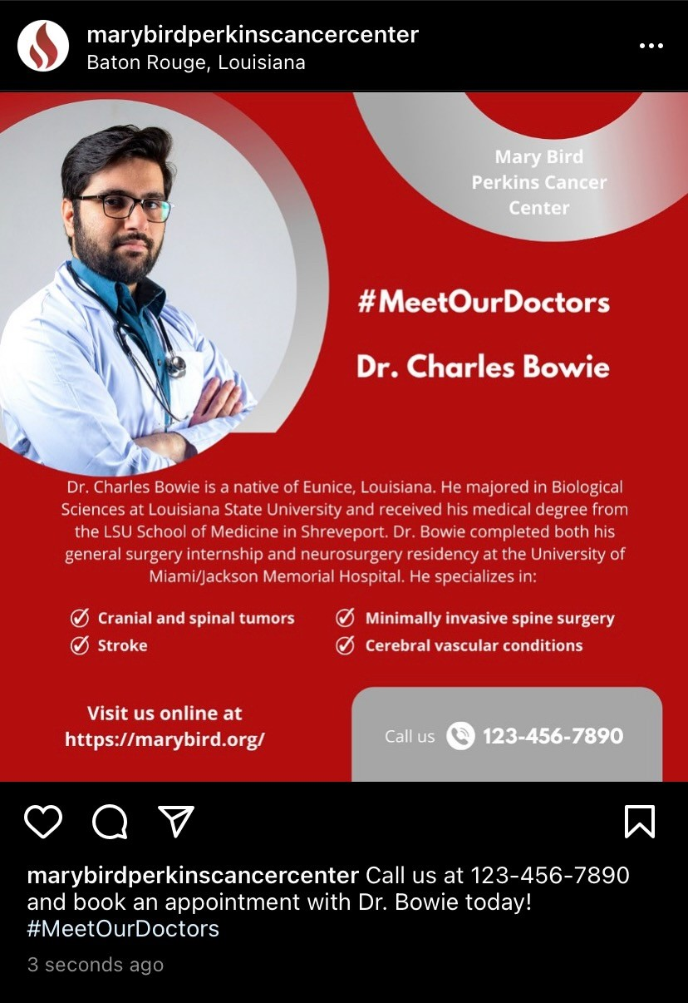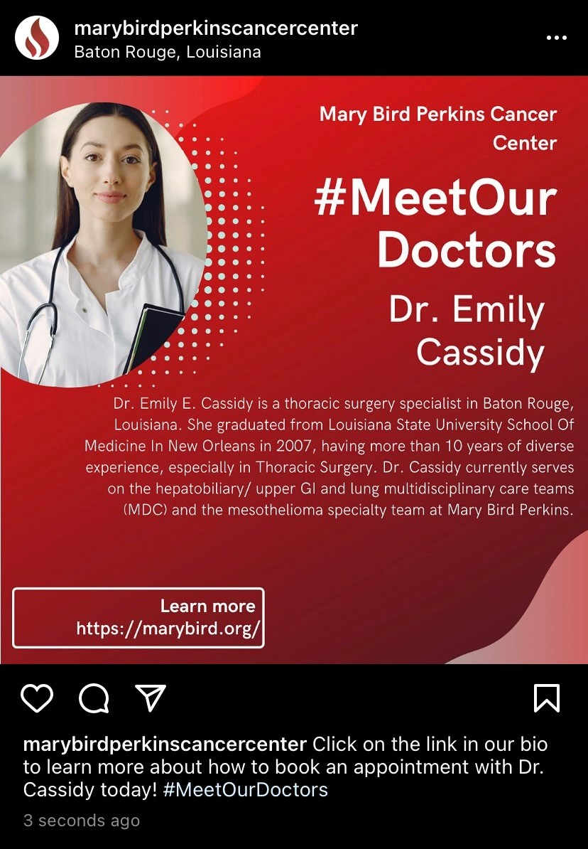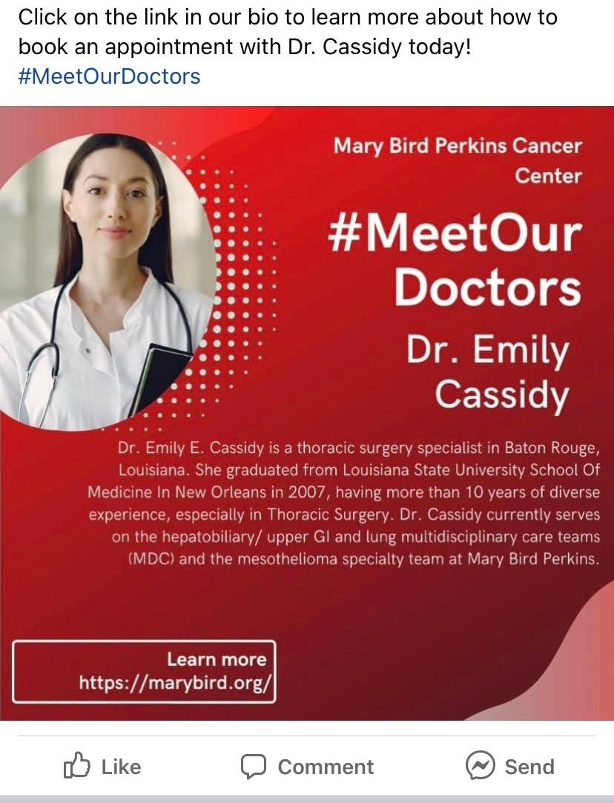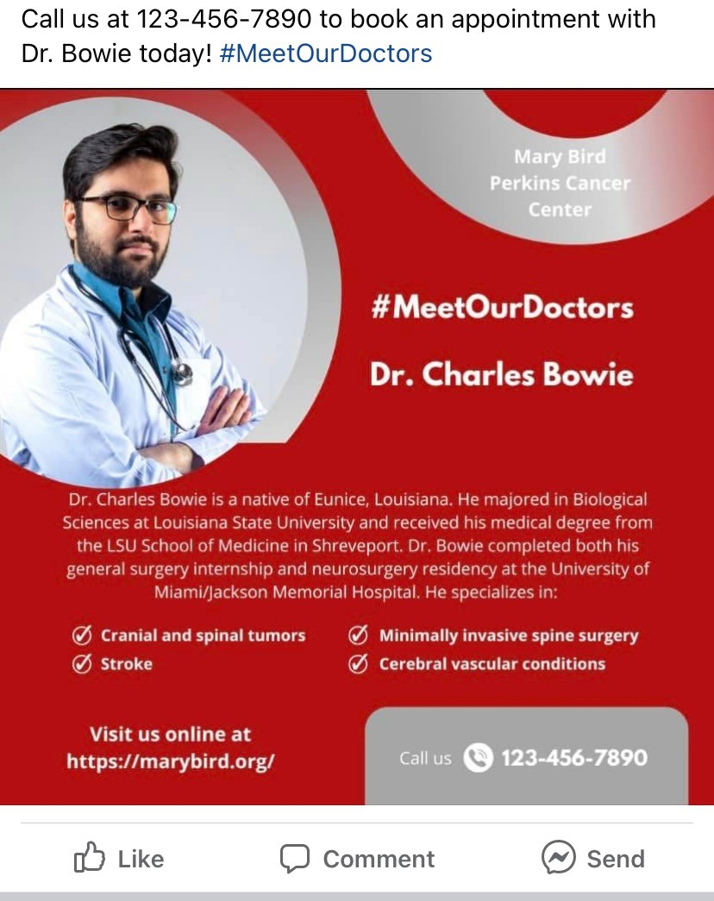

The content will be posted on both Facebook and Instagram, which are the two most used social media platforms by the target audience. According to a Pew Research survey done in 2019, “Overall, Americans tend to trust science practitioners, who directly provide treatments and recommendations to the public, more than researchers working in the same domains (Funk).” These posts will help renew a trusting relationship between Mary Bird Perkins and the Baton Rouge community. We believe that with our #MeetOurDoctors, we will reinstate a sense of transparency that has been blurred by recent media blasts. Through transparency, we will build a better bond between Mary Bird Perkins and the Baton Rouge community.

The second set of posts will promote Mary Bird Perkins’ informative website. The Facebook and Instagram posts will educate and inform while also asserting Mary Bird Perkins as a leader in cancer information. A key point to these posts however is that they are designed to drive traffic to the website. We hope through shedding light on educating the public about cancer and the resources available at Mary Bird Perkins Cancer Center, we will increase traffic to the website.
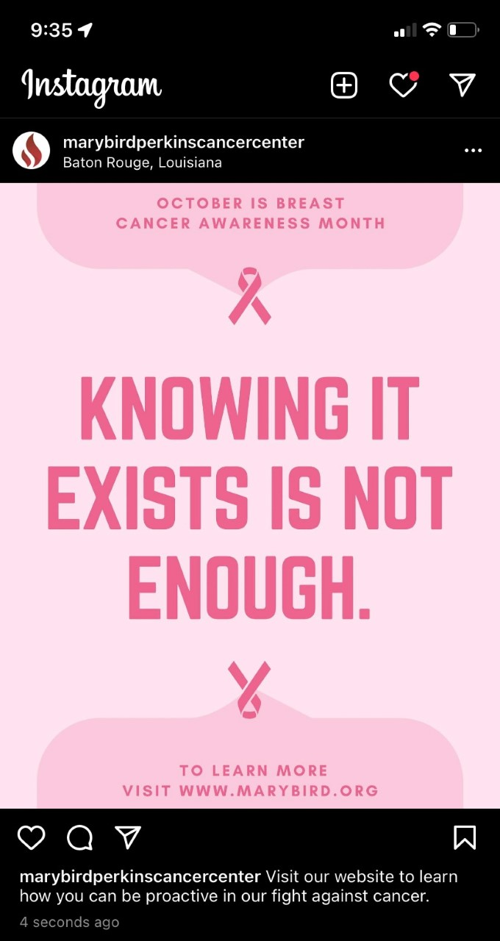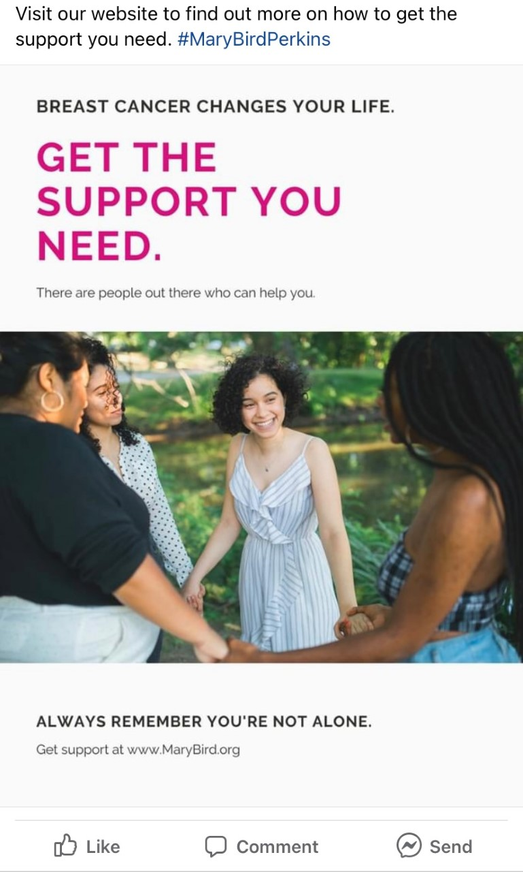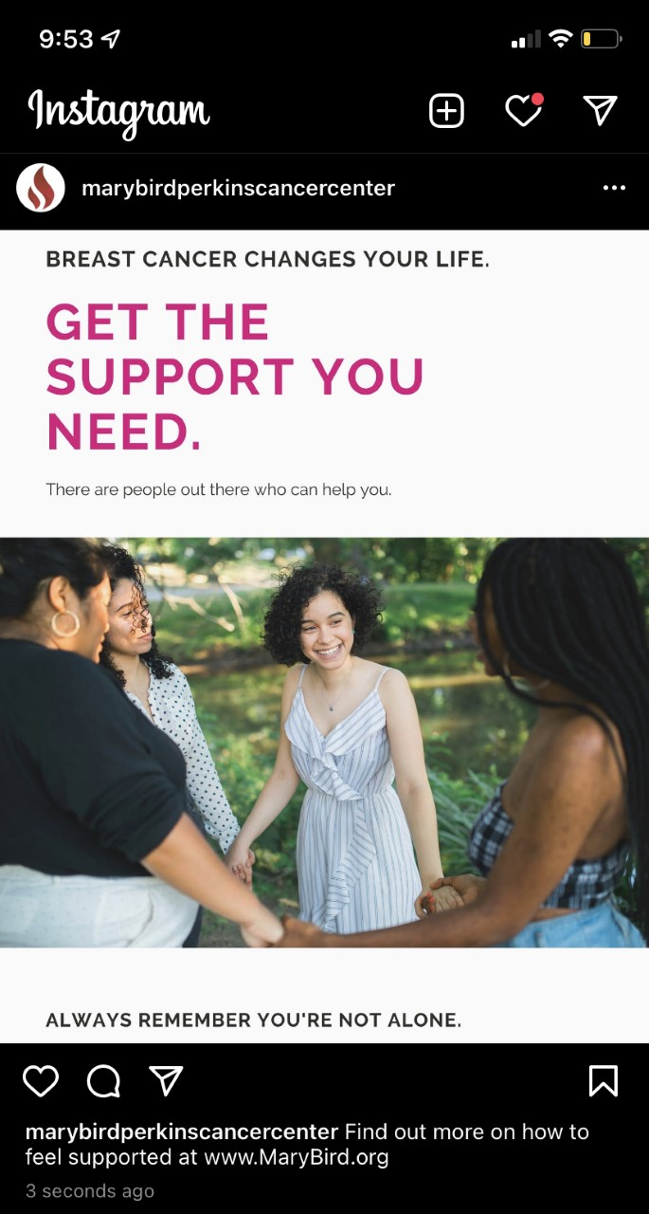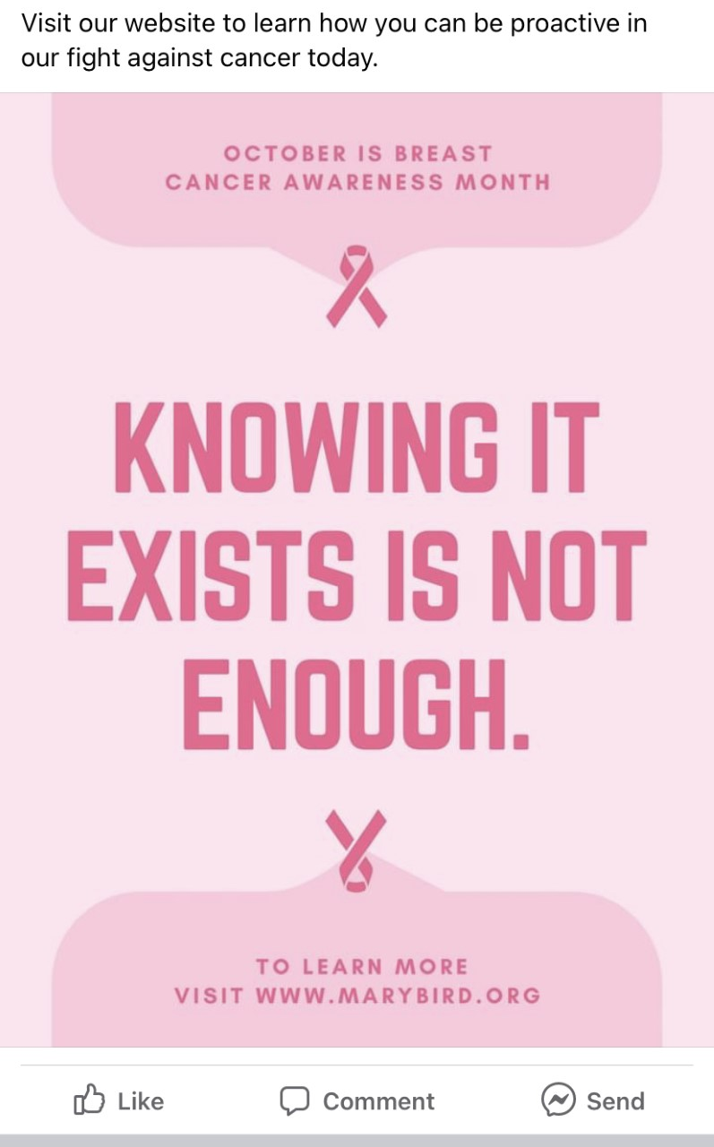

Alongside the social media and website promotion, Mary Bird Perkins Cancer Center plans to hold a family fun day on Dec. 15th in honor of Mary Bird Perkins’ 50th-anniversary. The event will be held in Independence Community Park and will be free to the public. However, in order to measure the success of this tactic, guests will have to register for the event. When registering guests will have to provide their email. Once the event is over this email will be used to send out a post-event survey gauging guests’ attitudes and opinions. Games and music will be provided and food trucks will be invited. On Dec. 1st a press release will be sent out detailing the event and how families can register. The press release will be sent to The Advocate and 225 Magazine. Below is a copy of the flyer for the event. At the event, brochures will be available detailing the work Mary Bird Perkins has done over the past 50 years, as well as Mary Bird Perkins’ hopes for the future. These tactics will reinforce the message that Mary Bird Perkins Cancer Center has delivered the most advanced cancer care for the past 50 years through compassion and excellence and remains a community leader.

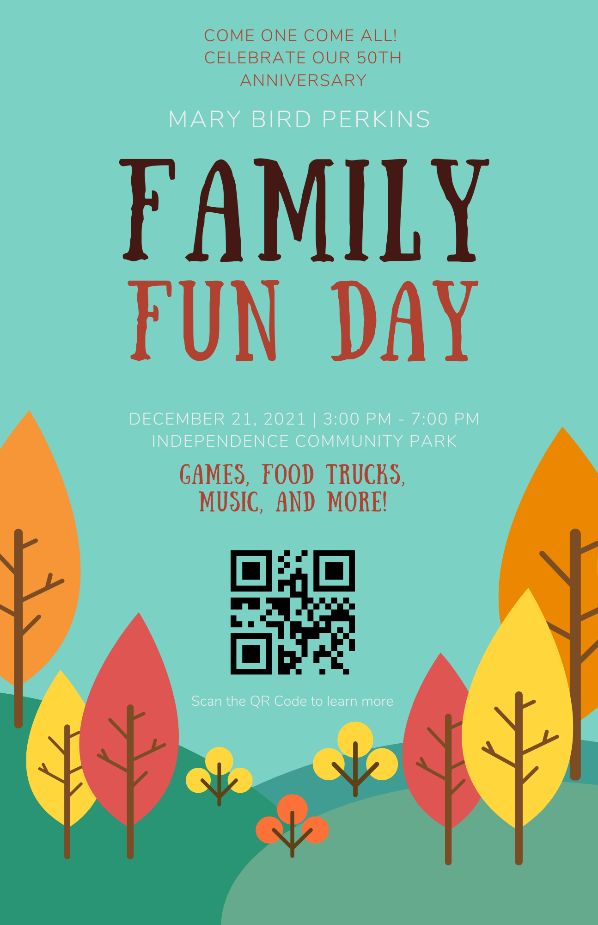

Timetable

November | Prepare content for employee and community communication campaigns.  Prepare for Family Fun Day.
December | Prepare media pitches and news releases for outreach.  Conduct Family Fun Day and distribute brochures.
January | Launch the social media campaign.
February | Continue contacting local magazines and newspapers.  Distribute a second news release.
March | Post social media stories about trusted physicians and information on how to stay proactive and detect cancer early.
April | Evaluate the campaign’s effectiveness.

Budget, Resources and Staffing
Total Budget: $108,125
- Agency fees: $18,125
  - 145 hours of work at $125 per hour
  - 50 hours for employee and in-hospital communication
  - 90 hours for traditional and social media campaigns
  - 5 hours for evaluation

- Expenses: $90,000
  - 100 signs: $10,000
  - 500 posters: $1,500
  - 30,000 brochures: $35,000
  - Social media graphics: $3,000
  - News release distribution: $500
  - Event vendors: $40,000
    - $25,000 - Redstick Entertainment inflatables, tables, chairs, staging, face painters, Santa Claus, pony rides, trackless train and carnival games
    - $5,000 - Venue
    - $10,000 - Food vendors

Evaluation
Assessment
This campaign seeks to reinstate Mary Bird Perkins as a leader in cancer treatment in the community, to increase awareness about the services and treatments that Mary Bird Perkins Cancer Center provides and to increase social media engagement. The objectives of this campaign are to have at least 200 families attend a family fun day on Dec. 15th in honor of Mary Bird Perkins’ 50th-anniversary, to have a 15% increase in website traffic by Dec. 21st and to have a 15% increase in social media engagement on both Facebook and Instagram by Dec. 21st.

Social media growth will be measured through the built-in Facebook and Instagram analytics. Facebook Business Suite provides in-depth information and insights for both Facebook and Instagram. This service provides metrics, trends and visual reports about social media content. Through this service, this campaign will be able to track a 15% growth as well as see the demographics of those interacting, sharing, liking and commenting on the posts. This information will also show which types of posts were interacted with the most. A similar program will be used to measure the traffic of Mary Bird Perkins’ website. Google Analytics will provide information about user behavior. It will measure a 15% increase in traffic but will also provide valuable information about user demographics, the content audiences are visiting the most, bounce rates, session duration and pages per session.

The success of the family fun event will be measured by the number of guests as well as the results of the post-event survey. The email provided when registering will receive the post-event survey which will include questions gauging guests’ knowledge and opinions about Mary Bird Perkins. A survey was chosen to evaluate the success of the event because of a survey’s ability to gather relatively in-depth information about respondents’ attitudes and beliefs. This survey will be valuable in evaluating key audiences’ opinions about Mary Bird Perkins. It will also evaluate whether or not this campaign achieved the goal of reassuring the community about Mary Bird Perkins’ continuing commitment to Baton Rouge, Louisiana.

Recommendations
After the assessment and evaluation of the campaign, it would be in Mary Bird Perkins Cancer Center’s best interest to continue the social media posts, engaging with the Greater Baton Rouge area and implementing a monthly e-newsletter. With the continuation of biweekly social media posts, the nonprofit will maintain the transparency between Mary Bird Perkins and the local community. Continued engagement with community members will increase followers, website visits and showcase the organization’s dedication to the community. Implementing a monthly e-newsletter will allow employees and community members the opportunity to stay up-to-date with Mary Bird Perkins’ cancer research, state-of-the-art facility and efforts to lessen the burden of cancer.

We believe that with this campaign, as well as our recommendations, Mary Bird Perkins will be reinstated as a leader in cancer treatment in the community in 2022.

